Project Planning Phase

**Project Planning Template (Product Backlog, Sprint Planning, Stories, Story points)**

|  |  |
| --- | --- |
| Date | 5 Nov 2022 |
| Team ID | PNT2022TMID24896 |
| Project Name | Web phishing detection |
| Maximum Marks | 8 Marks |

# Product Backlog, Sprint Schedule, and Estimation (4 Marks)

Use the below template to create product backlog and sprint schedule

|  |  |  |  |  |  |  |
| --- | --- | --- | --- | --- | --- | --- |
| **Sprint** | **Functional Requirement (Epic)** | **User Story Number** | **User Story / Task** | **Story Points** | **Priority** | **Team Members** |
| Sprint-1 | Home page | USN-1 | First impression of the homepage as a user, and I can explore and see how the website functions | 20 | Medium | Sharon  Sowmika  Sruthi  Anumesh |
| Sprint-2 | Login | USN-2 | User can login for the application . | 20 | Medium | Sharon  Sowmika  Sruthi  Anumesh |
| Sprint-2 |  | USN-3 | User can log into the application by entering email & password |  | low | Sharon  Sowmika  Sruthi  Anumesh |
| Sprint-3 | Dashboard | USN-4 | User would go through the funtionalities and the uses of the website | 5 | low | Sharon  Sowmika  Sruthi  Anumesh |

|  |  |  |  |  |  |  |
| --- | --- | --- | --- | --- | --- | --- |
| **Sprint** | **Functional Requirement (Epic)** | **User Story Number** | **User Story / Task** | **Story Points** | **Priority** | **Team Members** |
| Sprint-3 | Prediction | USN-5 | The user would be able to determine whether the website is legitimate or fraudulent. | 15 | High | Sharon  Sowmika  Sruthi  Anumesh |
| Sprint-4 | Result page | USN-6 | The user can access the analysis' results web page. | 20 | Medium | Sharon  Sowmika  Sruthi  Anumesh |

# Project Tracker, Velocity & Burndown Chart: (4 Marks)

|  |  |  |  |  |  |  |
| --- | --- | --- | --- | --- | --- | --- |
| **Sprint** | **Total Story Points** | **Duration** | **Sprint Start Date** | **Sprint End Date (Planned)** | **Story Points Completed (as on Planned End Date)** | **Sprint Release Date (Actual)** |
| Sprint-1 | 20 | 6 Days | 24 Oct 2022 | 29 Oct 2022 | 20 | 29 Oct 2022 |
| Sprint-2 | 20 | 6 Days | 31 Oct 2022 | 05 Nov 2022 | 20 | 05 Nov 2022 |
| Sprint-3 | 20 | 6 Days | 07 Nov 2022 | 12 Nov 2022 | 20 | 12 Nov 2022 |
| Sprint-4 | 20 | 6 Days | 14 Nov 2022 | 19 Nov 2022 | 20 | 12 Nov 2022 |

# Burndown Chart:

A burn down chart plots the amount of work remaining to perform against the amount of time. In agile software development approaches like Scrum, it is frequently employed. Burn down charts, however, can be used for any project that makes observable progress over time.

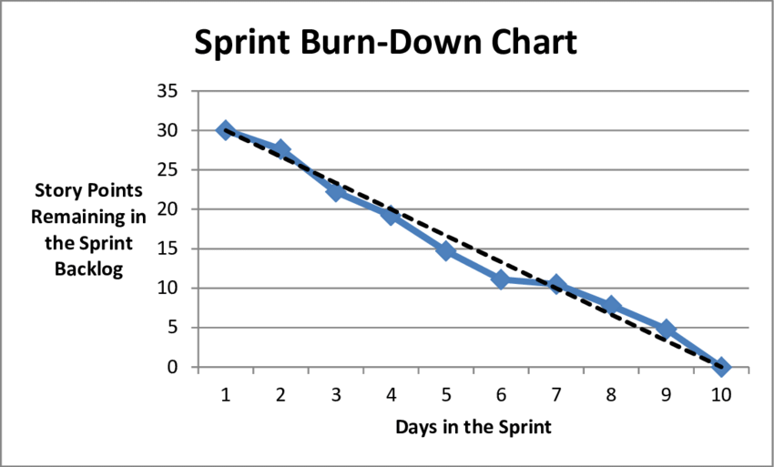

**VELOCITY:**

Our project has a sprint duration of six days, and the team's velocity is 20. (points per sprint). Let's determine the group's average velocity (AV) for each iteration (story points per day)

